1.1 SELECT *

FROM Expenses ;

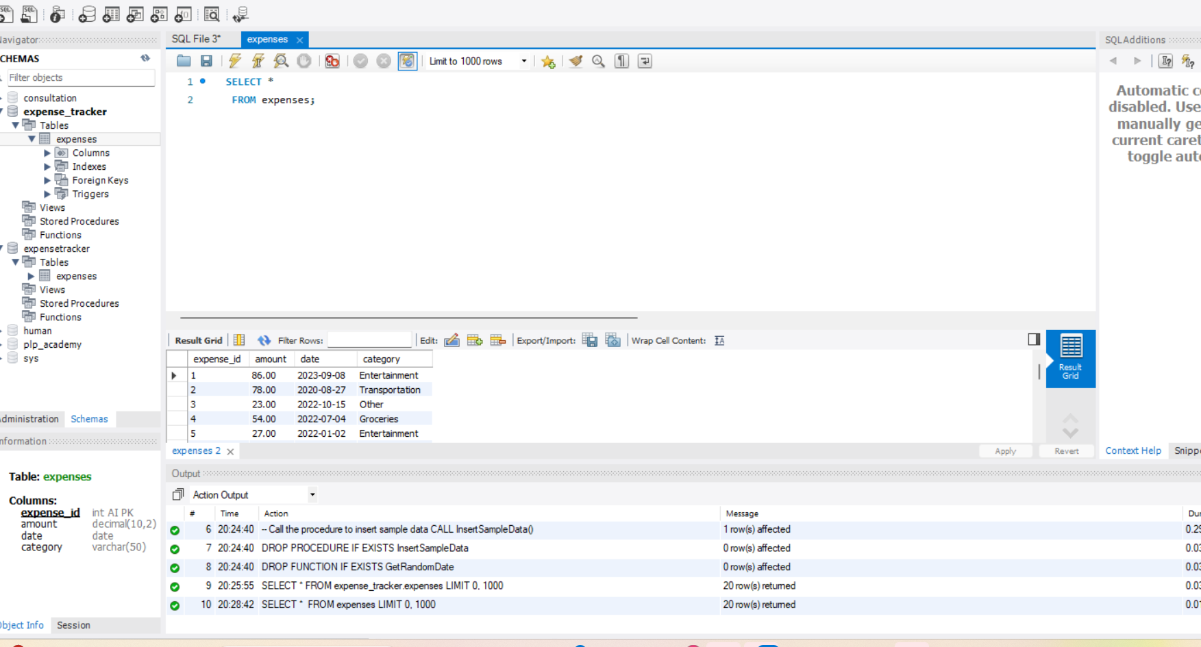

1.2 SELECT Date, Category, Amount

FROM Expenses;

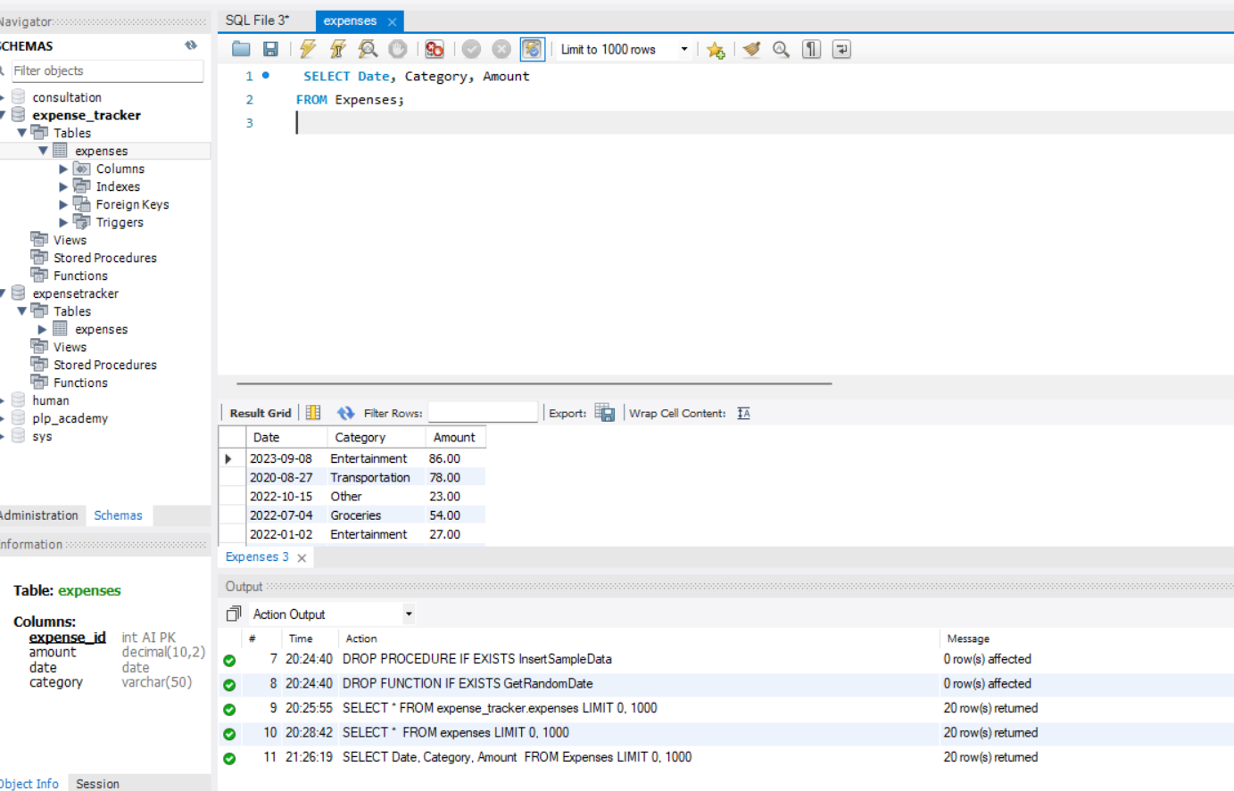

1.3 SELECT *

FROM expenses

WHERE date >= '2021-01-01' AND date <= '2024-12-15';

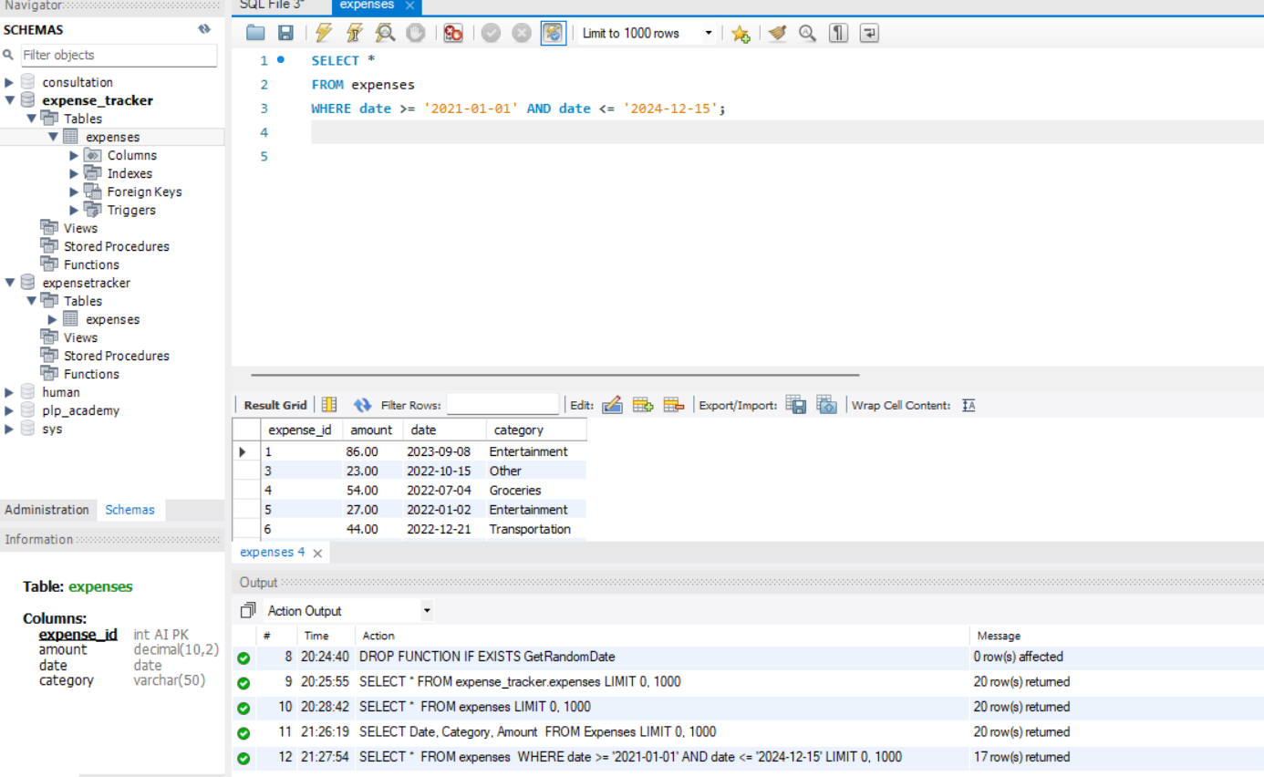

Part2

2.1 SELECT category

FROM Expenses

WHERE category = ‘Entertainment’;

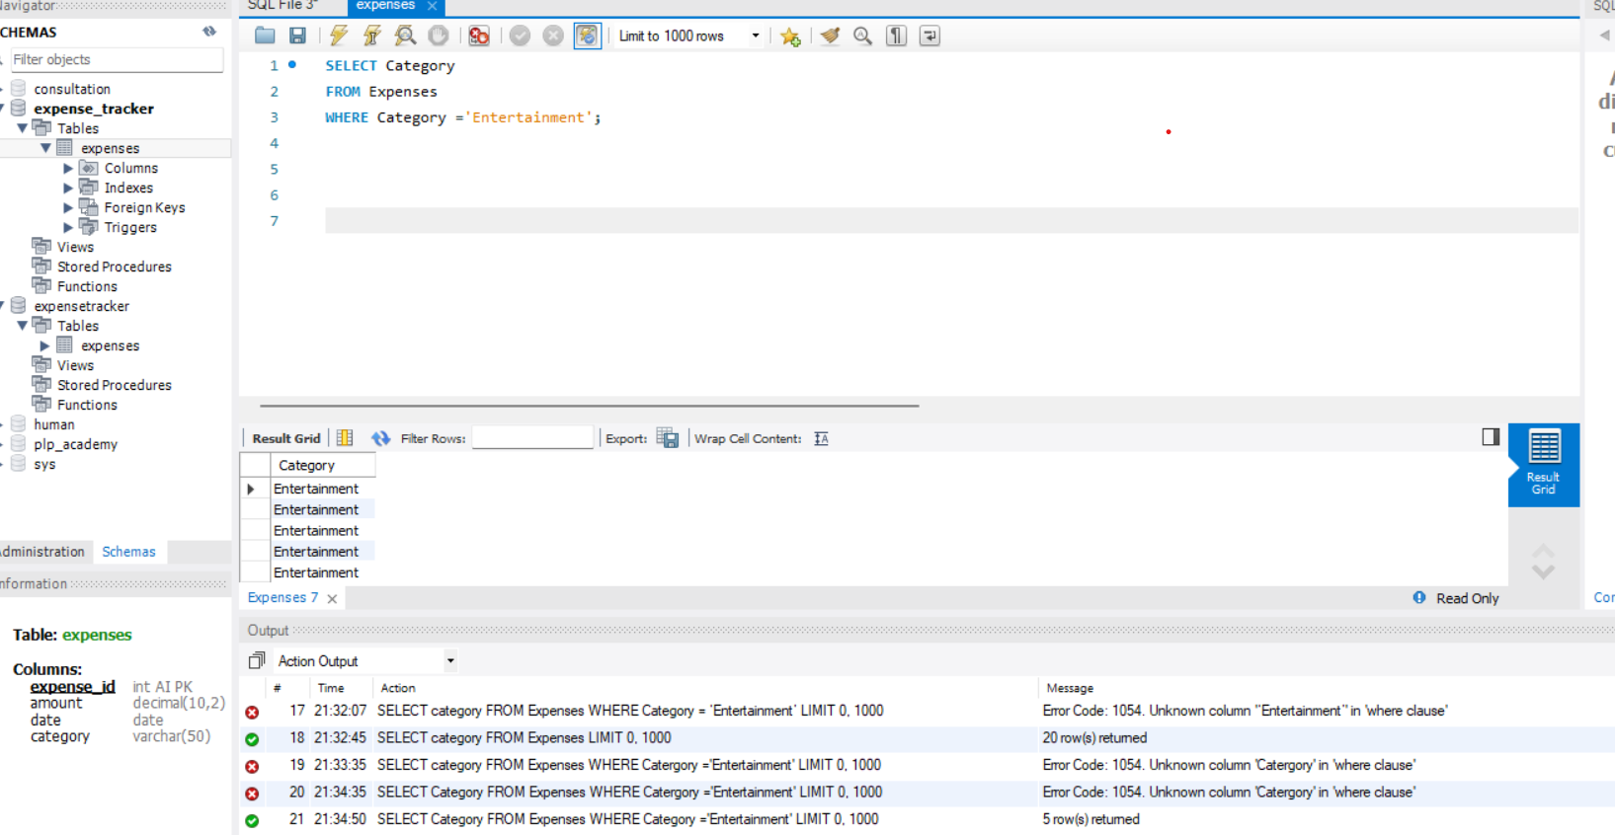

2.2 SELECT amount

FROM Expenses

WHERE amount > $50;

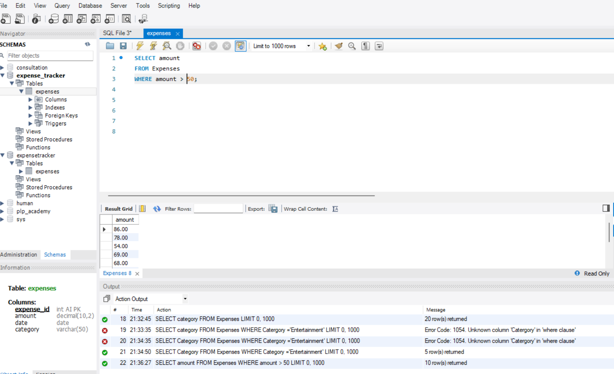

2.3 SELECT amount, category

FROM Expenses

WHERE amount >$75 AND category = ‘Food’:

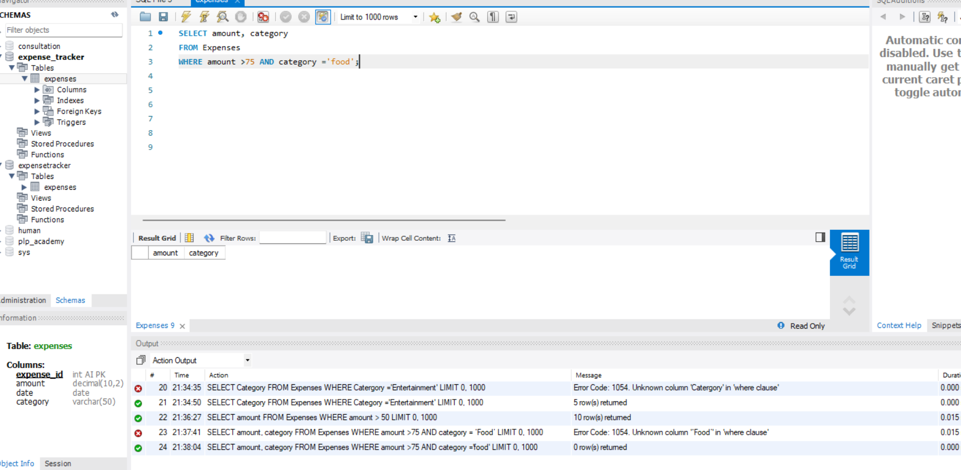

2.4 SELECT category

FROM Expenses

WHERE Category = 'Transportation' OR Category = 'Groceries';

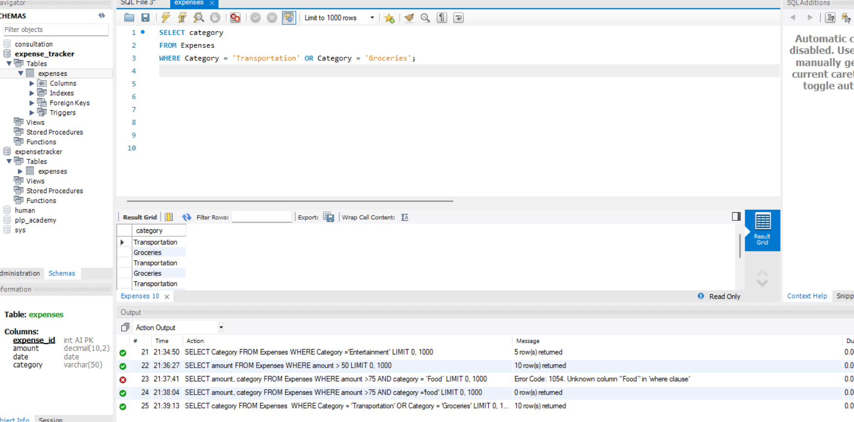

2.5 SELECT category

FROM Expenses

WHERE category <>’Rent’;

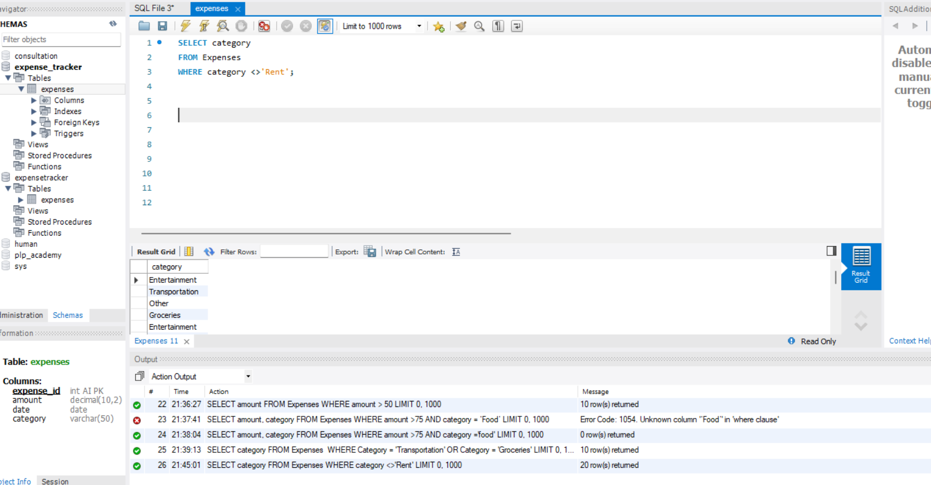

PART3

3.1 SELECT amount

FROM Expenses

ORDER BY amount DESC;

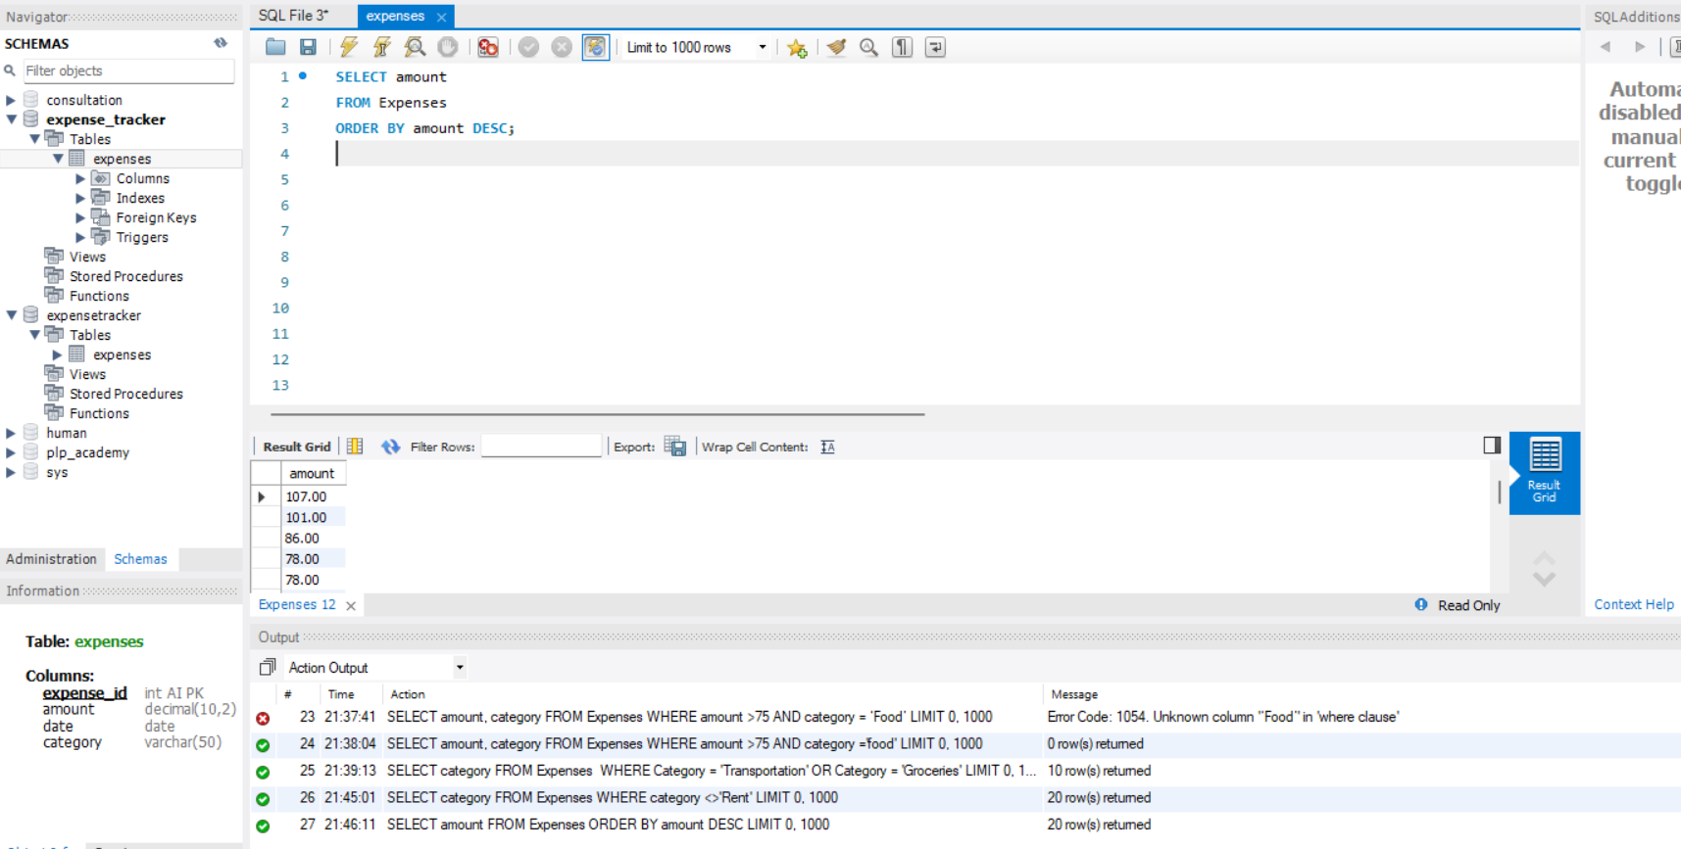

3.2 SELECT date, category

FROM Expenses

ORDER BY date DESC, category ASC

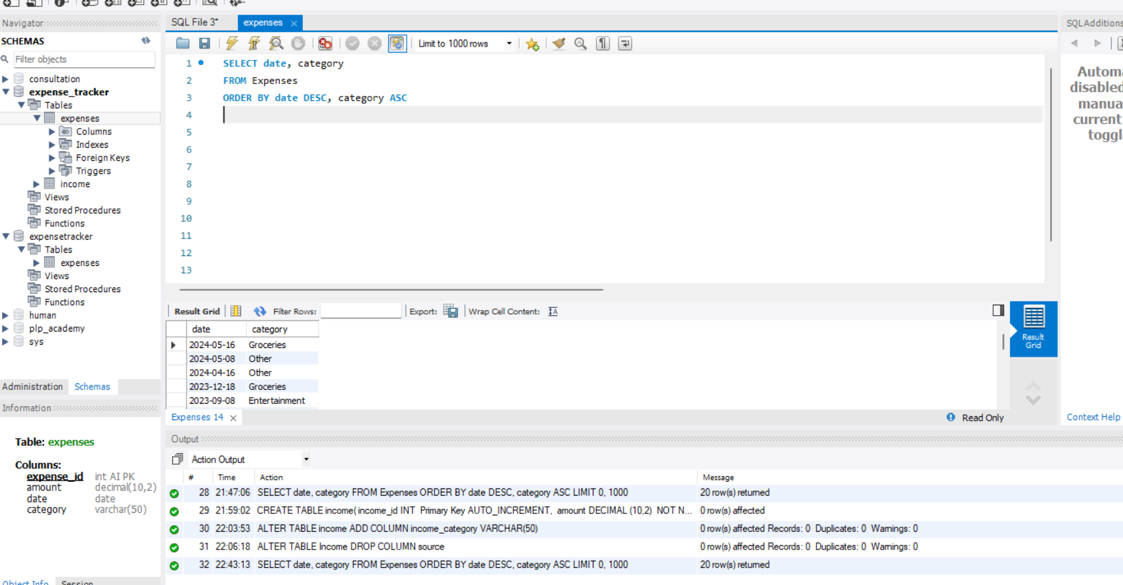

4.1 Write SQL commands to achieve the following:

CREATE TABLE income(

income_id INT Primary Key AUTO_INCREMENT,

amount DECIMAL(10,2) NOT NULL,

date DATE NOT NULL,

source VARCHAR(50) NOT NULL

);

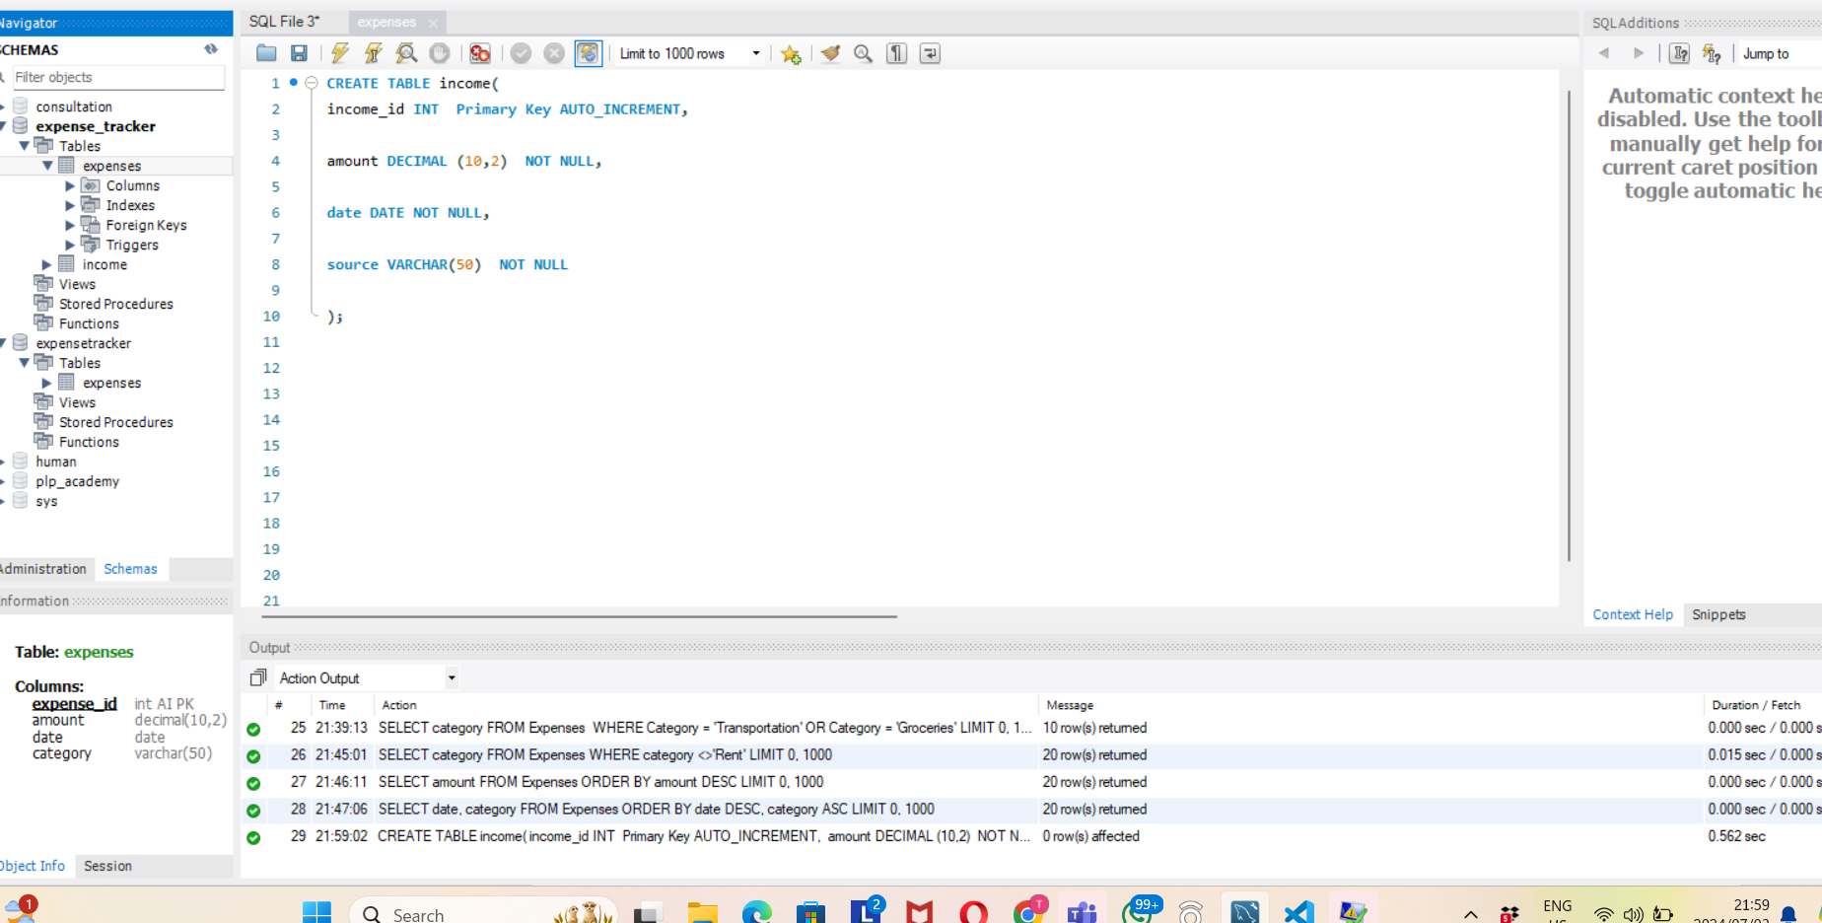

4.2

ALTER TABLE income

ADD COLUMN income_categoey VARCHAR(50);

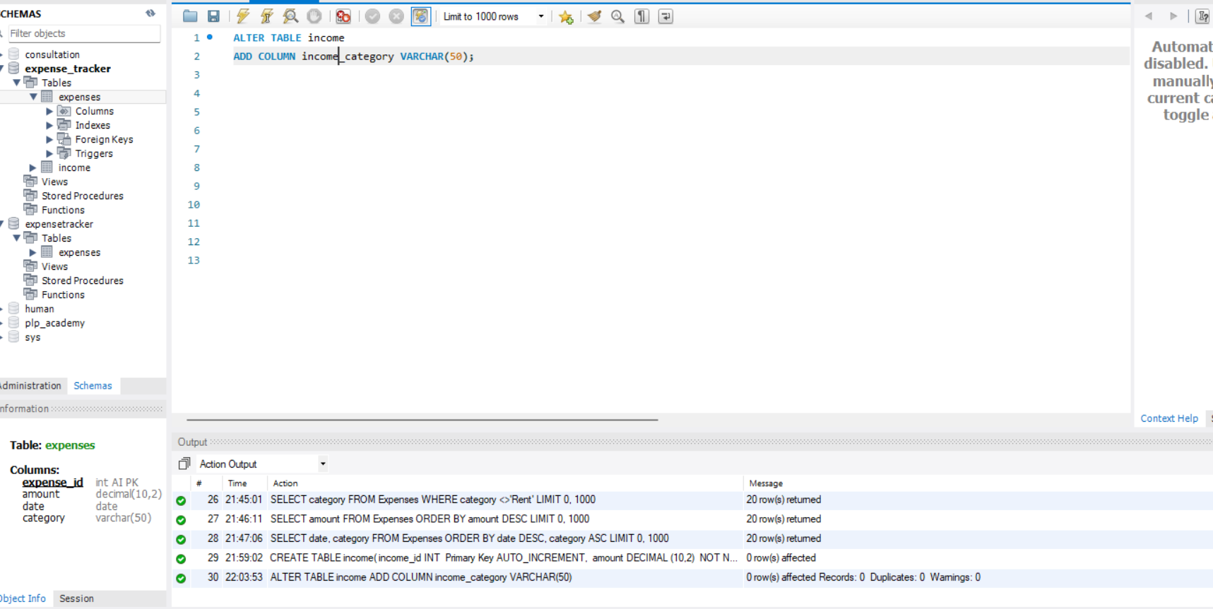

4.3

ALTER TABLE income

DROP COLUMN source;

